 | CHAROTAR UNIVERSITY OF SCIENCE & TECHNOLOGY  DEVANG PATEL INSTITUTE OF ADVANCE TECHNOLOGY AND RESEARCH | 

Weekly Report
In this report students require to mention the work has been done during the week and planning for the next week. (Please fill individual report for each week)

Student ID: 20DCE137 | Student Name: Parth Vaghela
From Date:16/05/2022 | To Date:21/05/2022
Semester:05 | Internship ID: RAO0107

Work done in last week (Attach supporting Documents):

1. Revised basics of html.
2. Revised basics of CSS.
3. Design some web pages such as cat photo app, a café
Menu, Set of color marker , Registration page , Rothko
Painting, Photo Gallery.(source freecodecamp.org responsive
Web design course )

Plans for next week:

1.Continuing freecodecamp webpages.
2.Designing a Rao infotech website using basic html &css

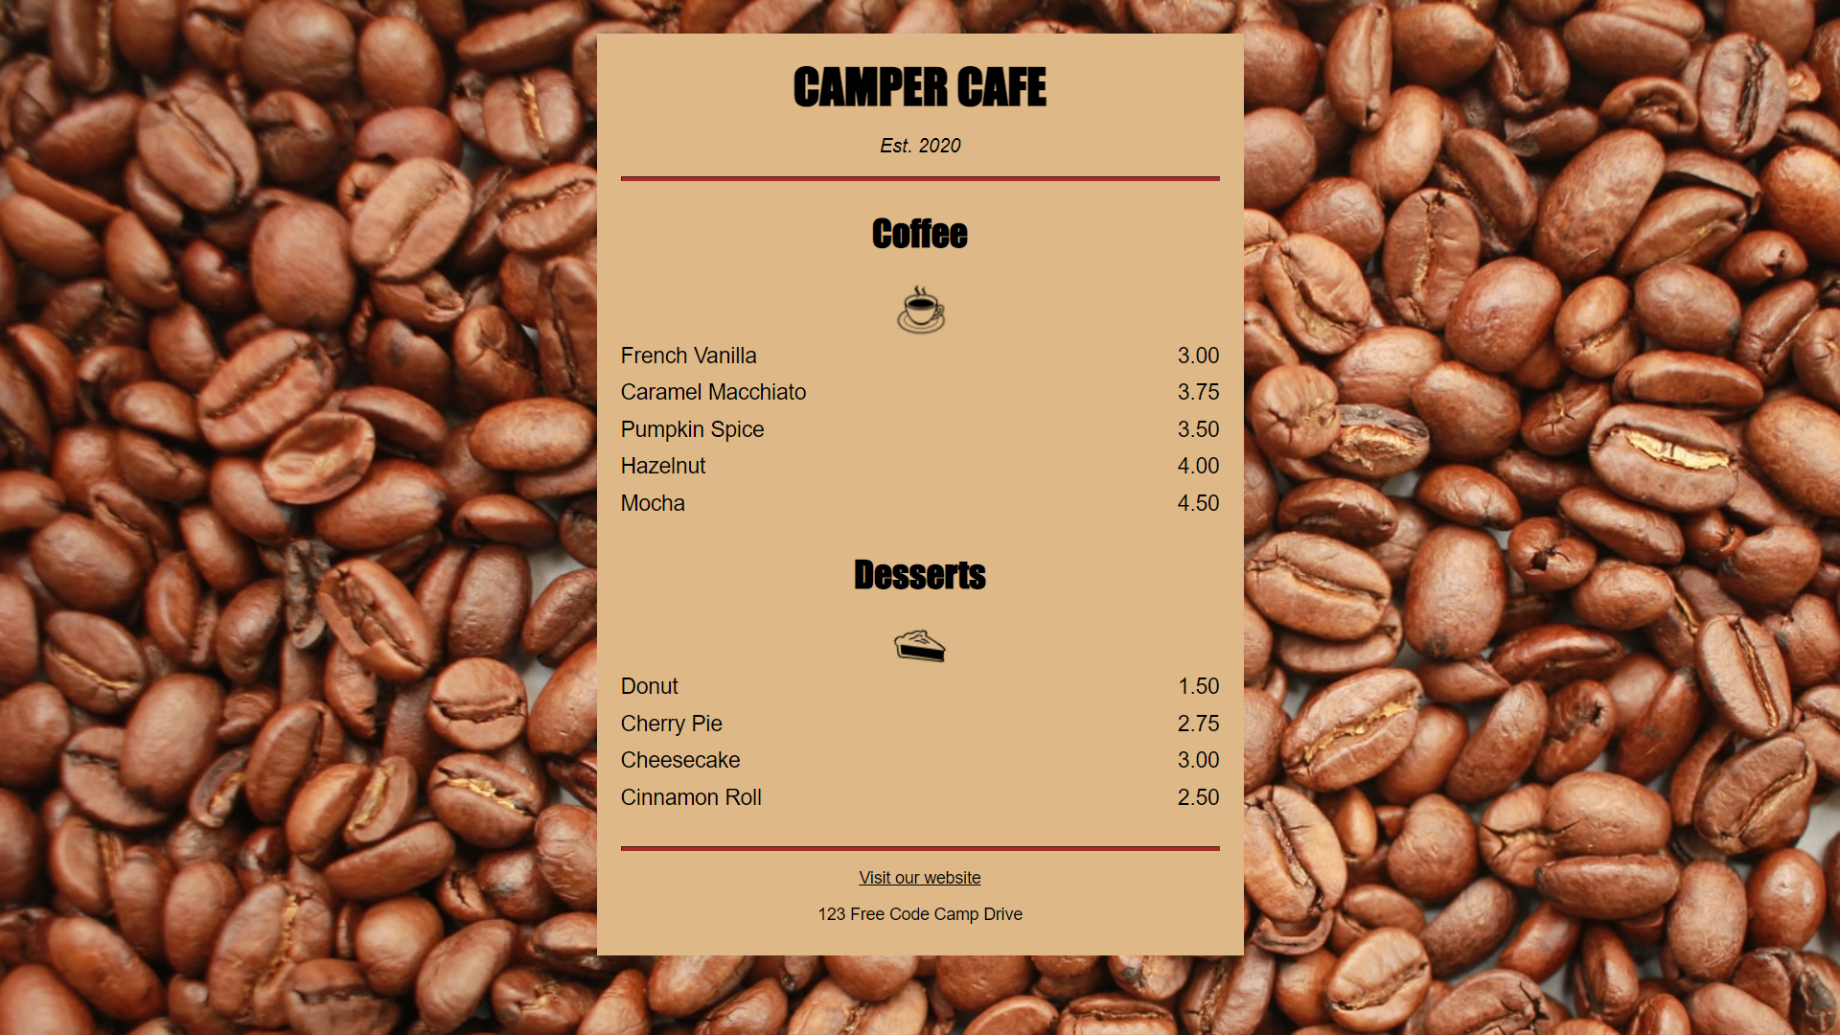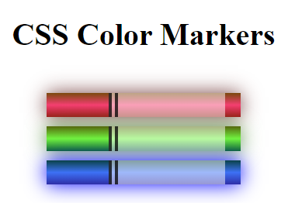
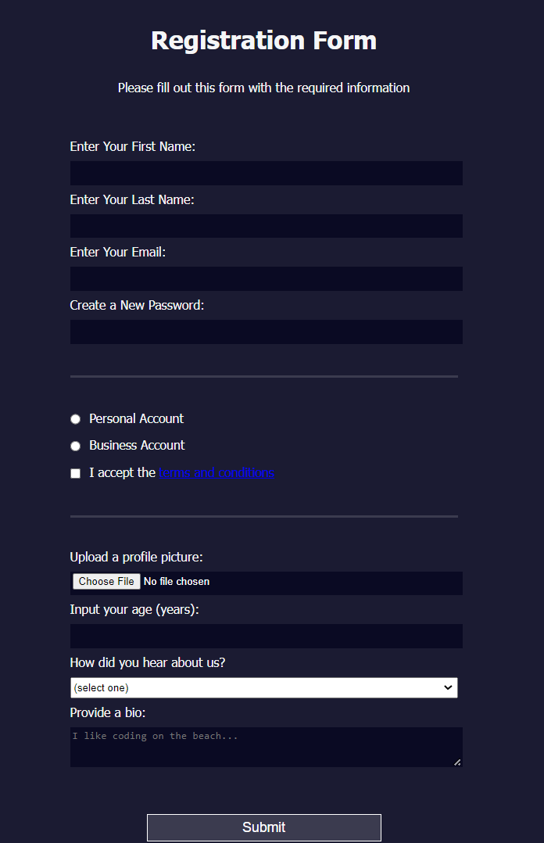

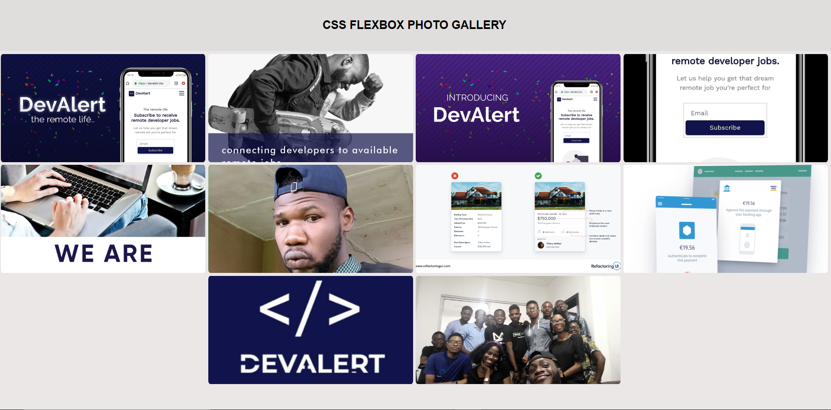

Source code:

https://github.com/parth9104/Internship-2022

References:
https://www.w3schools.com/
https://www.freecodecamp.org/

Signature of External Guide Signature of Internal Guide

